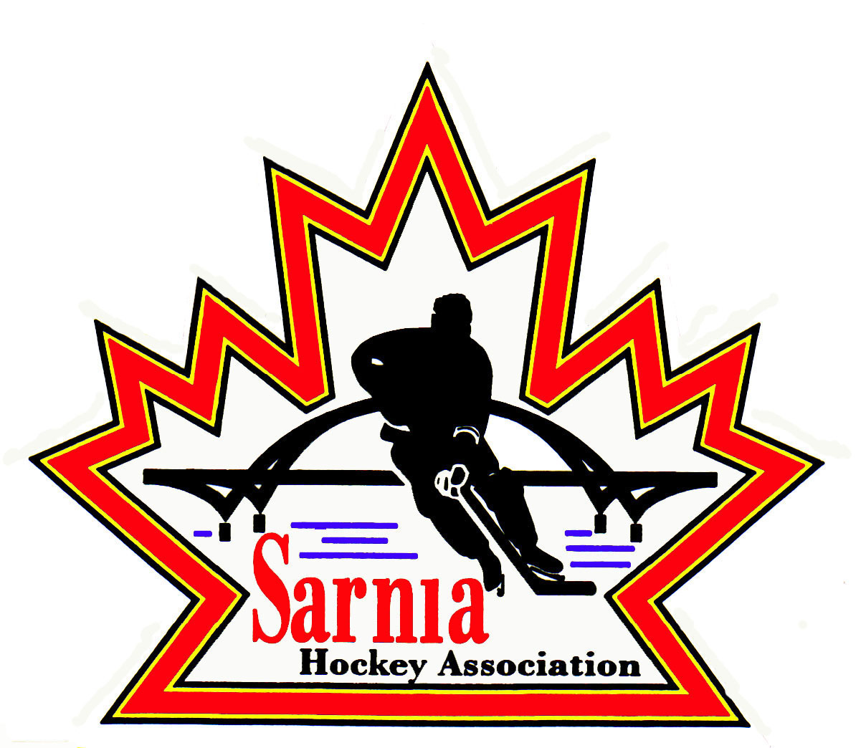

Sarnia Hockey Association

Minutes | Date: FEBRUARY 4, 2025 | time 7:00 pm

Meeting called by | Paul Walsh, President
Type of meeting | Regular
Secretary | Kelly Lane, Recording Secretary

Welcome | Paul Walsh, President, and meeting Chair welcomed everyone and called the meeting to order at 7:08 pm.

ATTENDANCE | Heather Amaral, Andrew Beasley, Jacquie Beasley, Jerry Bernardo, Alister Brown, Emily Brown, Brendan Douglass, Chuck Ewart, Jeff Fogal, Pat Forbes, Terry Gray, Kelly Lane, Linda Lauzon, John Mellor, Kyle Mellor, David Penner, John Ritchie, Wayne Scarrow, Lesley Smith-Taylor, Kevin Taylor, Paul Walsh, Barb Walsh  Regrets: Darren Chevalier, Ian Dunn, Bonny Marcy, Jeff Needham, Ted Pendle, Jason Teather, Tim Turner  Guests: Trevor Orrange

ACCEPTANCE OF MINUTES | MOTION #250204-001  “That the Minutes from January 22, 2025, be accepted as presented.” (J. Mellor/K. Mellor)  Carried

TREASURER’S REPORT | - Financial report was sent out to the Board via email.  - There was revenue from 4 Bingo’s in month of December.  - Benevity grants continue to come in. It may take months for money to flow through.  - Ice costs lower than expected. Large ice bill to be approved at this meeting.  MOTION #250204-002  “That the Treasurer’s report be accepted as presented.” (E. Brown/Forbes)  Carried

BILLS TO BE PAID | MOTION #250204-003  “That the bills be paid as presented.” (E. Brown/Bernardo)  Carried  - Kyle Mellor to review BRA invoice prior to paying for Silver Stick referees.
  Recipient | Expense | Amount
  Darkhorse Goaltending  John’s Restaurant  John Mellor  Paul Walsh  Kevin Taylor  All Season’s Trophies  Darren Rogers  Planet Stitch  Bluewater Referees  City of Sarnia | Cousi funded coaching for U8 MD, U10 B/BB, U14 B/BB, U15 Rec  January Silver Stick volunteer meals  Silver Stick Out of Pocket expenses  Travel expenses to Alliance President and Semi-AGM  Travel/incidentals to Alliance Semi AGM  Silver Stick plaques  U7 and U9 PEP sessions  Year end gifts  January referee bill  January Silver Stick ref bill  Miscellaneous room rentals  Ice – Rep, Rec, Winter Classic  Silver Stick ice  Silver Stick Ice | $ 900.00  $ 3,535.74  $ 100.29  $ 148.40  $ 165.90  $ 365.56  $ 723.20  $ 2,542.50  $ 6,450.00  $12,174.00  $ 176.00  $91,679.72  $23,222.62  $25,184.43

PREVIOUS MEETING FOLLOW UP | GAME CURFEWING:  - Follow up was completed by reviewing Live Barn.  - There was inconsistency between different age groups, referees, timekeepers etc.  - There is opportunity for best practice for games set for one hour (50 min ice time) to maximize the full 50 minutes for games.  - Our policy is when the Zamboni doors are closed, teams should be ready to enter the ice.  - Our policy is straight time, but some timekeepers are stopping the clock to put in penalties while others were not stopping the clock. All timekeepers need to be aware they should not be stopping the clock.  - In between each period there were breaks taken. There should be only one minute break between periods.  - Celebration after the game impacts the start of the next game if time has expired.  - Coaches need to ensure players are ready and, on the ice, quickly.  - Not all timekeepers know to start the clock as soon as players are on the ice for the 3-minute warmup, so this needs to be communicated.  - Message to rep teams that are on before rec games is that they need to get off the ice on time.  - Need to ensure that the sheet with best practices is in the timekeepers box so that we maximize the ice available.  - It was noted that everyone likes the weekday games for Rec.

REP DIRECTOR | - Rep Director attended the President’s meeting, Semi-annual and Rep Council meeting on January 25.  - There was discussion about Hockey Canada U9 pilot, but no updates are available yet.  - VSC’s for 2025/26 were discussed. The website will be a little more user friendly. If coach/volunteers have a valid VSC it is for a 3-year cycle. There have also been changes to the declaration screening form.  - Current VSC upload closes Feb 15.  - It opens again for 2025/26 season on March 15 for new coaches.  - Volunteers can also do declaration on March 15 for next season.  - Alliance Hockey Award nominations are due March 1.  - Team registration has been inputted.  - Tournament sanctions for next year are complete.  - There was a call for next years’ host.  - Reviewed playoffs and play downs.  - Player movement is well defined within OHF now for U10 and above.  - Anything below that is for Association to make decision on how they will treat it.  - Alliance is asking Associations for feedback if they want player movement for U9 and below within the Alliance. Up to this Association to provide feedback to the Alliance. This would only be within the Alliance. This will be discussed at our next board meeting.  - There was discussion about the dressing room policy and focusing on rule of two and facility respect. Feedback from facilities that were surveyed is abuse by teams such as showing up to games early and leaving bags around, and inappropriate music blaring during warmups.  - Cell phones are not to be used in the dressing room with more of a focus on supervision.  - HP1 Clinic registration is coming up.  - Ice Schedulers will be invited to the Rep Council meeting when discussions occur about 2025/26 Structure.  - Home Team warm up pucks – whether pucks being supplied by home team for warm up to stop potential fights when players retrieve pucks from the other end.  - Request re handshakes. Currently Alliance policy is post game handshake unless at the discretion of referees. U14-18 shake hands at conclusion of series.  - There was discussion about doing it at the beginning of the game. Currently some issues with handshakes. OMHA and GTHL have gone to pre-game handshake. Alliance would be proposing to move to pre-game, but U14-18 at conclusion of series.  FOLLOW-UP FOR NEXT MEETING:  - Discussion about U8/9 player movement at next meeting.  - Handshakes at the beginning of the game to be discussed at next meeting.  PLAYER MOVEMENT:  - Need to discuss what SHA wants to do regarding player movement.  - The baseline is full player movement.  - We could supersede this policy on a case-by-case basis for special considerations.  - There was a lengthy discussion about player movement and what is best for our Association.  - The coach cannot offer a roster position on a team until the tryouts start. Players who register for tryouts are only guaranteed one (1) tryout. Players are allowed to register for tryouts at multiple centres at the same time. Coaches do not have to wait until the end of tryouts to offer roster positions to a player.  - Discussion about the potential impact of allowing any number of Sarnia-Lambton players for A/AA.  - We need a scenario that is competitive and offers the best hockey we can.  - If we continue with our development programs, we should have players that our competitive.  - Looking at having a hard number of Sarnia players.  MOTION #250204-004  “To accept Policy 2.02 Registration, Roster and Affiliate Submission Policy and Procedures as presented with the amendments as noted below.” (K. Taylor/L. Smith-Taylor)  Carried with one opposed  Add Regulations 2.02.05 (a) Eligibility to Roster: All participants must meet the applicable requirements that are set by OHF and Alliance to be eligible. Refer to SHA Policy 3.03 for additional eligibility requirements:  - “A” or “AA” carded teams may roster (max players per policy 3.02.01) up to:  - A minimum of five (5) slaters and one (1) goalie that are Sarnia residents;  - Up to ten (10) skaters and one (1) goalie that are Sarnia-Lambton residents;  - Up to three (3) skaters that are non-Sarnia-Lambton residents will be permitted.  - “B” or “BB” carded teams may roster (max players per Policy 3.02.01) up to:  - Any number of Sarnia residents;  - Up to three (3) skaters and one (1) goalie that are Lambton County residents residing outside of the City of Sarnia boundary;  - Up to two (2) skaters that are non Sarnia residents that have received SHA Rep Executive Committee approval.

POLICY CHANGE | - Two policy change requests by Vice President Administration:  MOTION #250204-005  “That we accept policy change request to modernize, update and amalgamate Policy 1.00, 1.01 and 1.02 into 1.01 Member Policy and Guidelines for Board of Directors.” (K. Taylor/K. Mellor)  Carried  - Need 4 people to be on Policy Review Committee: First Vice-President as initiator and Vice-President of Administration as well as Linda Lauzon, Alister Brown, Emily Brown.  - After Policy Review Committee, it comes back to the Board for approval.  - The change to Board Members not being head coaches/Team Managers can be discussed by the Policy Review Committee.  - Some rules added about Succession.  MOTION #250204-006  “That we update Policy 3.06 Expectations for Team Officials and add tampering.” (K. Taylor/Fogal)  Carried  - Along with player movement, there will be new rules regarding tampering.  - Proposed change adds definition of tampering.  - Added regulations regarding prohibition.  - If found guilty of tampering, there will be repercussions.  - Tampering needs to be reported.  - Training will be provided by OHF for our coaches to help protect themselves.  - Waiting on official OHF definition of tampering.  - We have to expedite this policy to start the process.  - If any coach is contacted for information, they are supposed to refer them to our SHA website for information.  - Need 4 people to be on the Policy Review Committee: First Vice-President as initiator and Vice-President of Administration as well as John Mellor and Terry Gray.

ICE DIRECTOR | - Final Days are scheduled for March 17-20.  - Mon U11, Tues U13, Wed U15 Wed, Thurs U18-21 and Saturday U7 and U9 in afternoon and Foundations on Red in the morning.  - Ice is coming out at Clearwater on March 30 for the Home Show. The City will put one pad back in after Home Show.  - Bills to be reviewed and sent out for extra ice.  - At Rep Council there was discussion about prep skates. AAA and SHA to work in co-ordination to schedule prep skates. We should co-ordinate body checking clinic with AAA as well. Prep skates need to be completed by April 18.  - AAA tryouts start April 19 for U11 and U13. Non OHF teams can start on April 19.  - Still waiting on whether U9 will be spring or fall tryouts. U8 will remain in the fall.  - Need to ensure pricing is the same for prep skates as AAA and SHA will likely have to do the registration and we can pay for the ice. We can set it up where players can pay per session.

PHOTOGRAPHY DIRECTOR | - Schedule has been emailed out.  - We are going to utilize the Sledge Hockey room on Clearwater Red to do photos.  - We could issue an Honorarium to Sarnia Sledge Hockey (offsetting what we normally would pay the City for room rental).  - Composite photos are taken and then these are put together in a team photo.  - Ideally, we would like to do photography in November once most of the rec team balancing is completed.  - We could potentially co-ordinate with Sarnia Girls Hockey who do their photos in October. We could have the rep team photos completed then.

REC DIRECTOR | REC COUNCIL MEETING:  - Rec Director attended the Alliance Rec Council meeting on January 25.  - There was discussion about tournament sanction applications.  - Calls for event hosts for Rec championships.  - Dressing Room Policy was also discussed, and Alliance wanted it reviewed and reiterated within our Association ie cell phone policy and supervision.  - Discussed player movement.  - Coaching requirements won’t change for next year.  - Discussed Jump Start, Kruger Assist and Women in Sport.  - Alliance wants to change the format and timing of the U7 Festival. They want a one-day event mid-season.

REC EQUIPMENT DIRECTOR | VOLUNTEER APPRECIATION NIGHT:  - April 14 is confirmed at Bocciodromo.

NEW BUSINESS | 2025/26 BOARD POSITIONS UP FOR ELECTION:  - SHA President identified what positions are up for election this year:  BOARD POSITIONS FOR ONE-YEAR APPOINTMENT:  - Board Members whose positions are up for election are asked to contact Nomination Committee members Wayne Scarrow or Paul Walsh with their intentions to run again or to identify interest in another position.  COACH AND MANAGER OF THE YEAR:  - Rec Directors to provide name of Coach of Year for Rec Divisions.  - A/AA and B/BB Directors to provide name of Coach and Manager of the Year for A/AA and B/BB.  - Names to be submitted to Alister Brown by March 7.  VOLUNTEER OF THE YEAR:  - Need nominations for Volunteer of the Year.  - This will be put out on our website. Need nomination and short paragraph on what they have done.  - Submit to Volunteer of the Year to Selection Committee that consists of Wayne Scarrow, Barb Walsh and Jerry Bernardo.  NEXT MEETING:  - Next meeting is Wednesday, February 19, 2025 at Pat Stapleton Arena Kiwanis Room.
  POSITION | CURRENT MEMBER
  First Vice-President | Kevin Taylor
  Vice-President Recreational League | Jerry Bernardo
  Director of Recreational League U15 | Dan Hunt
  Director of Recreational League-U11 | David Penner
  Director of Recreational League U6/U7 | Brendan Douglass
  Director of Recreational League Foundations | Jason Teather
  Director of A/AA Representative Teams | Terry Gray
  Development/Skills Director | Jeff Needham
  Ice Director/Scheduler | Linda Lauzon
  Recreational League – Tournament Director | Jeff Fogal
  Sponsorship Director – Recreational Teams | Jerry Bernardo
  Recreational League Referee Director | Ian Dunn
  Director of Mental Health | Tom Babcock
  Website Director | Andrew Beasley
  Equipment Director Representative Teams | Tom Babcock
  POSITION | CURRENT MEMBER
  Director at Large-AAA Representative | Tim Turner
  Director at Large-AAA Representative | Cris LaPointe
  Director at Large-Select Teams | Don McGugan
  Director at Large-Silver Stick Tournament | Paul Douglass
  Director at Large | John Ritchie
  Director of Fundraising | Bonny Marcy
  Alliance Rep Council | Paul Walsh
  Alliance Rec Council | Jerry Bernardo

adjournment | MOTION #250204-007  “That the meeting be adjourned.” (Scarrow/Mellor)  Carried

Paul Walsh Kelly Lane
President Secretary

